SF2: Image Processing Interim Report 1

**INTRODUCTION**

Images in various real world applications need to be compressed for efficient storage and computations. This report investigates briefly Laplacian pyramids and quantisation to this effect.

**SIMPLE IMAGE FILTERING**

An example image is filtered using a filter with impulse response equal to the half cosine pulse for various odd filter lengths.

ROW COLUMN AND COLUMN ROW FILTERING

It makes no difference whether the rows are filtered first or the columns. The absolute maximum deviation of an image row filtered first and then column filtered with an image column filtered first and then row filtered is infinitesimal: $1.1369×{10}^{-13}$, which implies that the images are the same.

LOW PASS AND HIGH PASS FILTERED IMAGES

Some low pass and high pass images filtered with various odd length half cosine filters are shown in the Appendix in Figure 1. It can be seen that the larger the filter length, the more blurred the low pass image is and the more detail is seen in the high pass images with some streak artefacts. The relative energies of the low pass and high pass filtered images is shown in Table 1 below.

Table 1. Energies for low pass and high pass filtered images (4 significant figures)

|  |  |  |
| --- | --- | --- |
| Filter length | Low pass energy ($×{10}^{6}$) | High pass energy ($×{10}^{6}$) |
| 3 | 1299 | 9.843 |
| 15 | 1275 | 31.65 |
| 51 | 1246 | 54.95 |
| 255 | 1202 | 102.0 |

**IMAGE ENTROPIES AND BITS FOR TRANSMISSION**

A Laplacian pyramid of images is constructed and the high pass images along with the smallest low pass image is quantised to a step size of 17 (15 distinct levels). For a one level pyramid quantised to 15 levels, the low pass image (X1) has an entropy of 3.4021 leading to 55740.0064 bits and the high pass image (Y0) has an entropy of 1.6208 leading to 106220.7488 bits. Compared to the original image’s (X) entropy of 3.4910 leading to 228786.176 bits, a saving of approximately 66825 bits is achieved.

Using more levels in the pyramid, the saving in bits can be calculated in a corresponding way. There seems to be a peak in bits saved by constructing the pyramid to 3 levels. Using more levels doesn’t save much more, if at all.

**RECONSTRUCTION FROM QUANTISED PYRAMID**

The image can be reconstructed from the quantised pyramid. A few example reconstructions can be seen in the Appendix in Figure 2, compared with the original image quantised. The RMS error for reconstruction from various levels is also plotted in the Appendix in Figure 3. The more the pyramid levels used, the greater the error since each image in the pyramid is quantised individually. Therefore, when reconstructed, the RMS error is larger for more levels as it includes contributions from more images. This is also why the quantised original image is different from a quantised reconstruction from the pyramid and gives a smaller RMS error of 4.934 compared to any reconstruction.

STEP SIZE FOR RMS ERROR MATCHING

In order to compare schemes it is essential to have the RMS error as the same compared to when the image is quantised directly. The quantisation step sizes that guarantee this are shown in Figure 4 in the Appendix when the original image is quantised to 15 levels.

**MSE CRITERION AND NON UNIFORM QUANTISATION LEVELS**

Each pyramid level can also be quantised with a different step size. This can be done by the MSE criterion, where each pyramid level contributes equally to the RMS error.

The data compression achievable, RMS error, maximum absolute deviation and visual quality can be compared for uniform and non-uniform quantising. Graphs showing these can be seen in the Appendix in Figure 5. It can be seen from these that non uniform quantisation achieves higher compression and also seems to give a better reconstructed image in terms of both RMS error and maximum absolute deviation. In each case, the optimum choice of layer depth depends on the metric to be optimised. For the highest compression ratio, the non-uniform scheme suggests it doesn’t matter whether you use anywhere between 3 to 7 layers, whereas the uniform scheme suggests 2 layers are best. For smallest maximum absolute deviation, both schemes suggest a 1 layered pyramid. The RMS error is roughly constant as it has been capped to be the same as that for quantising the image, although small deviations can be seen.

Visualising a 1 layered and 2 layered pyramid for both schemes would allow us to compare the visual quality of the images optimal in some sense. These can be seen in the Appendix in Figure 6, with some differences highlighted. The non-uniform scheme produces a less patchy sky and has some smoother effects in other parts. For a one level pyramid there are block artefacts which reduce significantly for the 2 level pyramid.

**CHANGING THE FILTER**

The same procedures can also be carried out with a different filter. Relevant results analogous to the previous section are plotted in the Appendix in Figure 7. The best compression ratio is achieved from the non-uniform scheme with filter of order 2 using 3 or more pyramid levels and the smallest max absolute deviation is obtained from using non uniform quantising with filter order 4 and 1 pyramid level. Reconstructing the images for these schemes shows interesting effects, which can be seen in the Appendix in Figure 8. The 3 level reconstruction is a lot smoother and appears better visually than the 1 level reconstruction. Compared to the filter with order 2, the smoothness is higher and the sky also seems darker.

**APPENDIX**

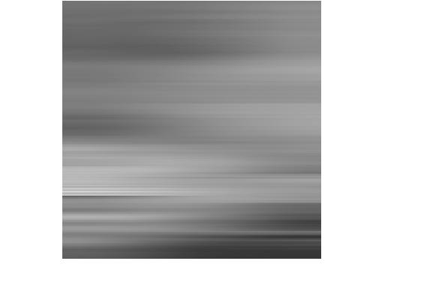

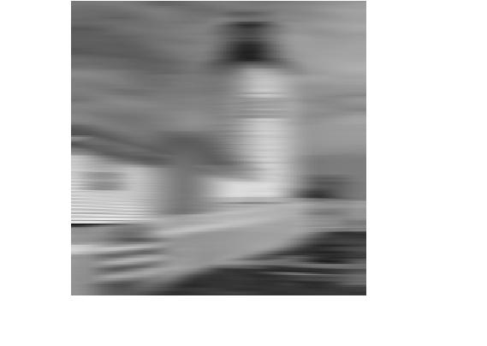

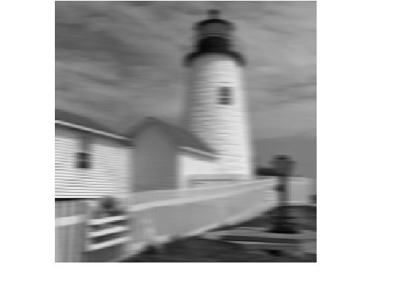

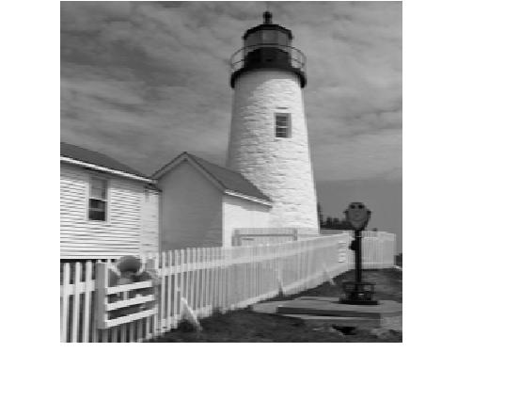

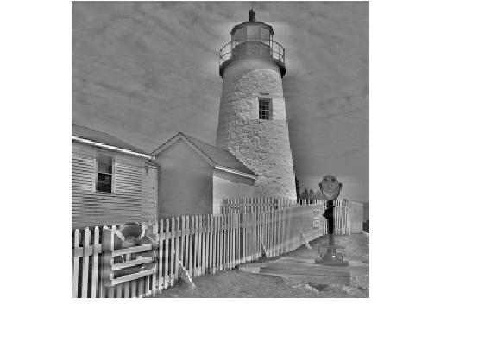

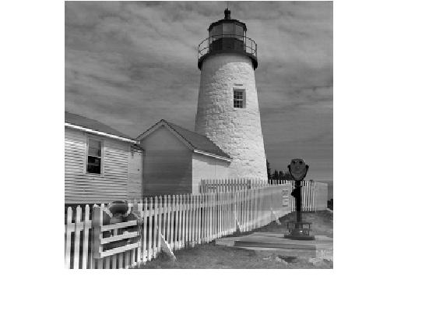

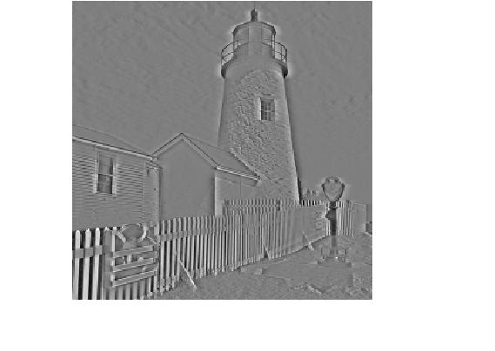

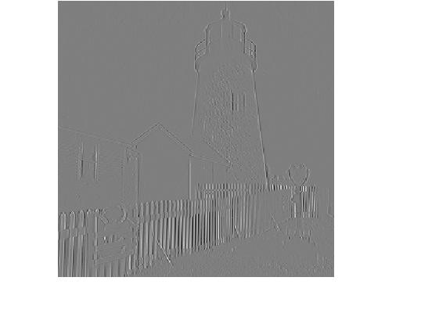

Figure 1. Low pass (upper) and high pass (lower) filtered images: filter length 3, 15, 51, 255

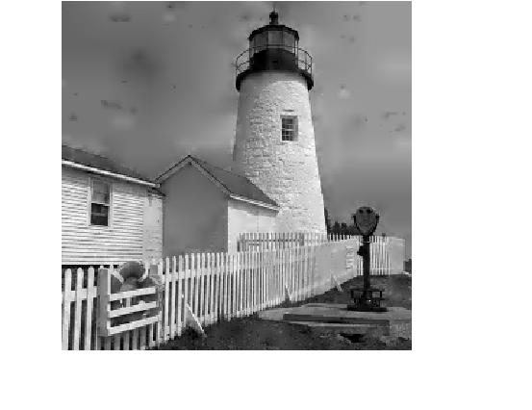

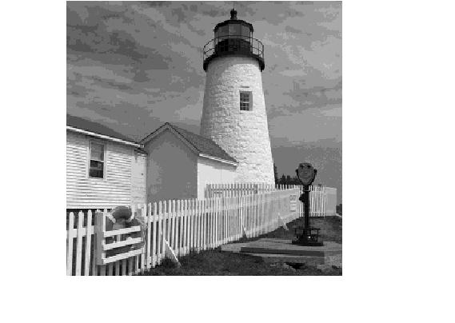

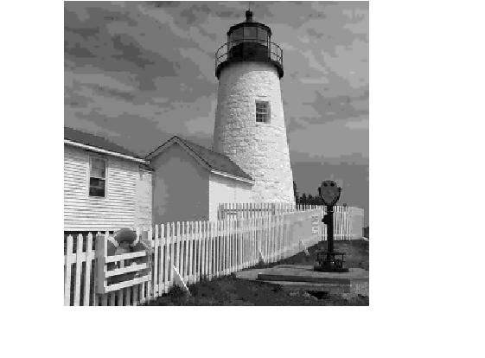

Figure 2. (Left to right) Reconstruction from 1 level, 7 levels and original image quantised

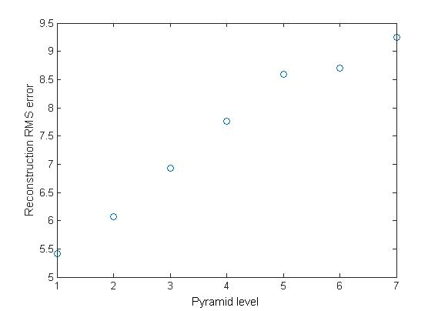

Figure 4. Step sizes for same RMS error in reconstruction as quantising original image to 15 levels

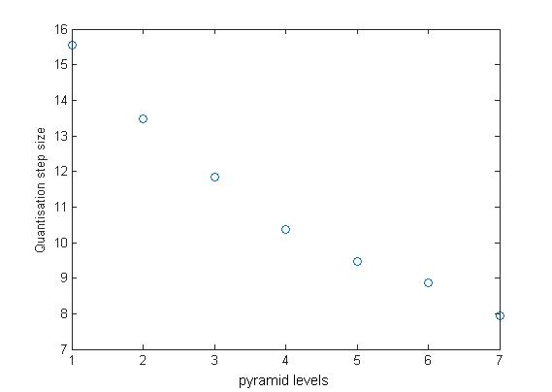

Figure 3. RMS error for quantised reconstruction from various pyramid levels

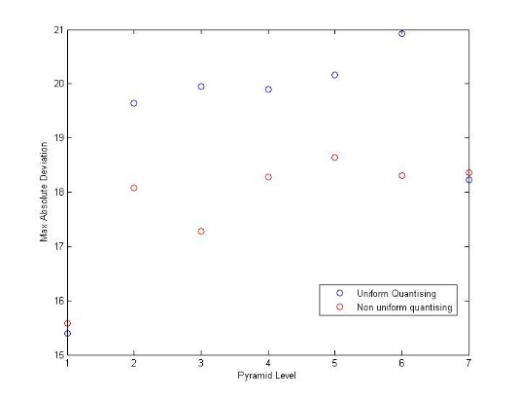

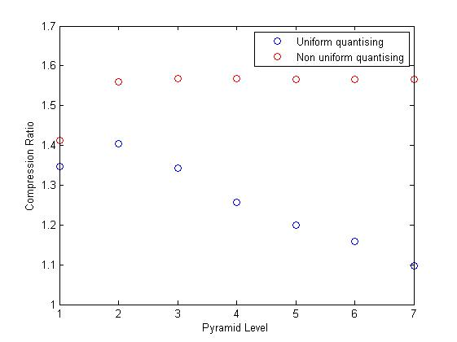

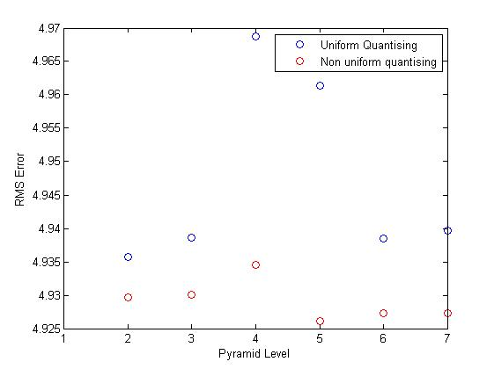

Figure 5. Max absolute deviation, RMS error and compression ratio for reconstruction

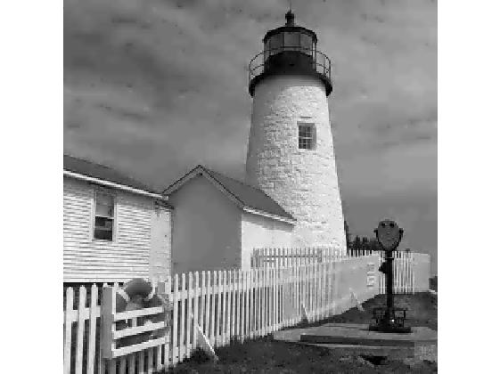

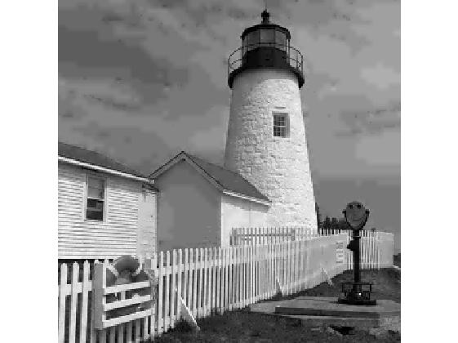

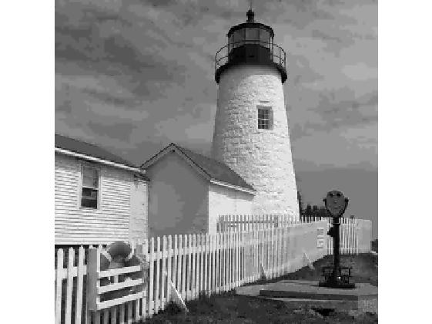

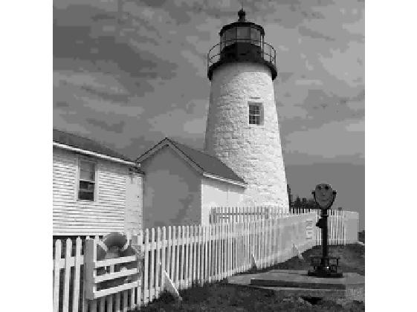

Figure 6b. Uniform (left) and non-uniform (right) quantisation reconstruction from 2 level pyramid.

Figure 6a. Uniform (left) and non-uniform (right) quantisation reconstruction from 1 level pyramid.

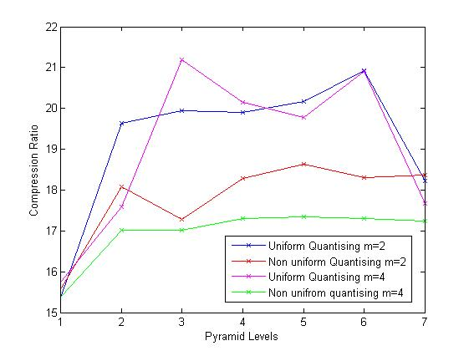

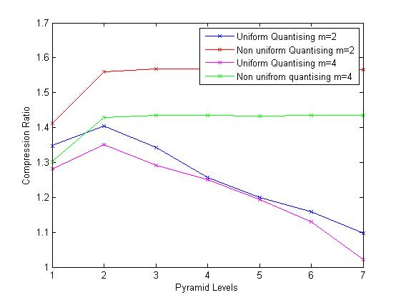

Figure 7. Compression Ratio and Max Absolute Deviation from using a higher order filter

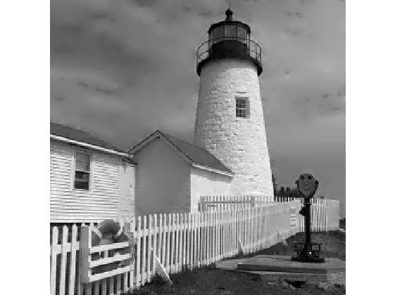

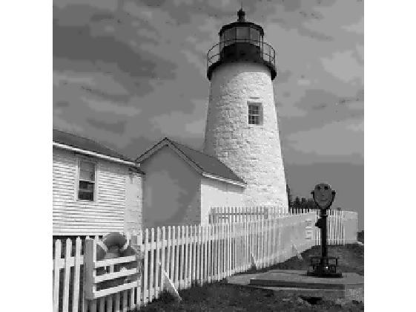

Figure 8. Reconstruction using filter order 4 from 1 level (left) and 3 levels (right)